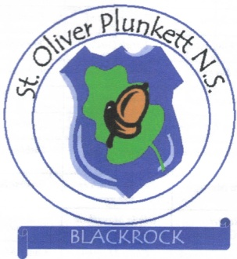

Addendum to Remote Learning Policy

St. Oliver Plunkett N.S. recognises the value of live lessons as a learning tool, and that it can be of immense value in the teaching and learning process. As a school we are called to act for the greater good of all our pupils, and unfortunately live lessons are not proving practical for a number of reasons:

- Connectivity – online connections struggle where a number of digital devices are being used simultaneously in a household. Teachers working from home may not always have internet connections strong enough to support live lesson provision.
- Where there are a number of school children in any given household, there may not be enough digital devices available for children to access live online provision during peak times of the ‘school day’.
- The home environment may be very busy (children accessing school provision / day to day living in the home/ parents or siblings working from home), and not as conducive to teaching and learning as is the classroom.
- Timetabling can prove difficult for already busy parents and younger children often struggle with concentrating online for extended periods. Teachers have pointed out that some children simply do not enjoy Zoom.

However, as per our Remote Learning Policy, we see great merit in weekly interaction among class groups for social interaction purposes. This is something our staff are currently working on, and we meet to share best practice.

Articles for consideration with this statement are:
- Our school Remote Learning Policy – available on our school website
- https://www.elevenplusexamstuition.co.uk/live-vs-recorded-lessons-how-to-prepare-for-the-11plus-during-lockdown/

